Project Design Phase Solution Architecture

Date | 02 November 2025
Team ID | NM2025TMID00163
Project Name | Laptop Request Catalog Item
Maximum Marks | 4 Marks

Solution Architecture:
Goals of the Architecture:
- Provide a system safeguard using a Business Rule
- Maintain data integrity across incident-user relationships
- Reduce manual monitoring for user deletions
Key Components:
- sys_user table (where users exist)
- incident table (linked via assigned_to)
- Business Rule (before Delete) on sys_user
- Script logic that checks active incident assignments
Development Phases:
- Create test users (e.g., Ajay, Kiran)
- Assign user to incident
- Implement Business Rule
- Attempt user deletion (test both assigned & unassigned cases)
Solution Architecture Description:
The solution architecture is designed to safeguard user integrity within the ServiceNow platform by implementing a Business Rule that prevents deletion of users who are currently assigned to incidents. The architecture focuses on ensuring data consistency across the ‘sys_user’ and incident tables, using a “before delete” Business Rule. This rule checks for any active associations between users and incidents through the ‘assigned_to’ field. If an assignment exists, the deletion is blocked automatically. The development process involves creating test users, assigning them to incidents, applying the business rule, and verifying the deletion behavior. This architecture reduces the need for manual monitoring, enhances system reliability, and promotes operational accountability in ITSM environments.

Example - Solution Architecture Diagram:

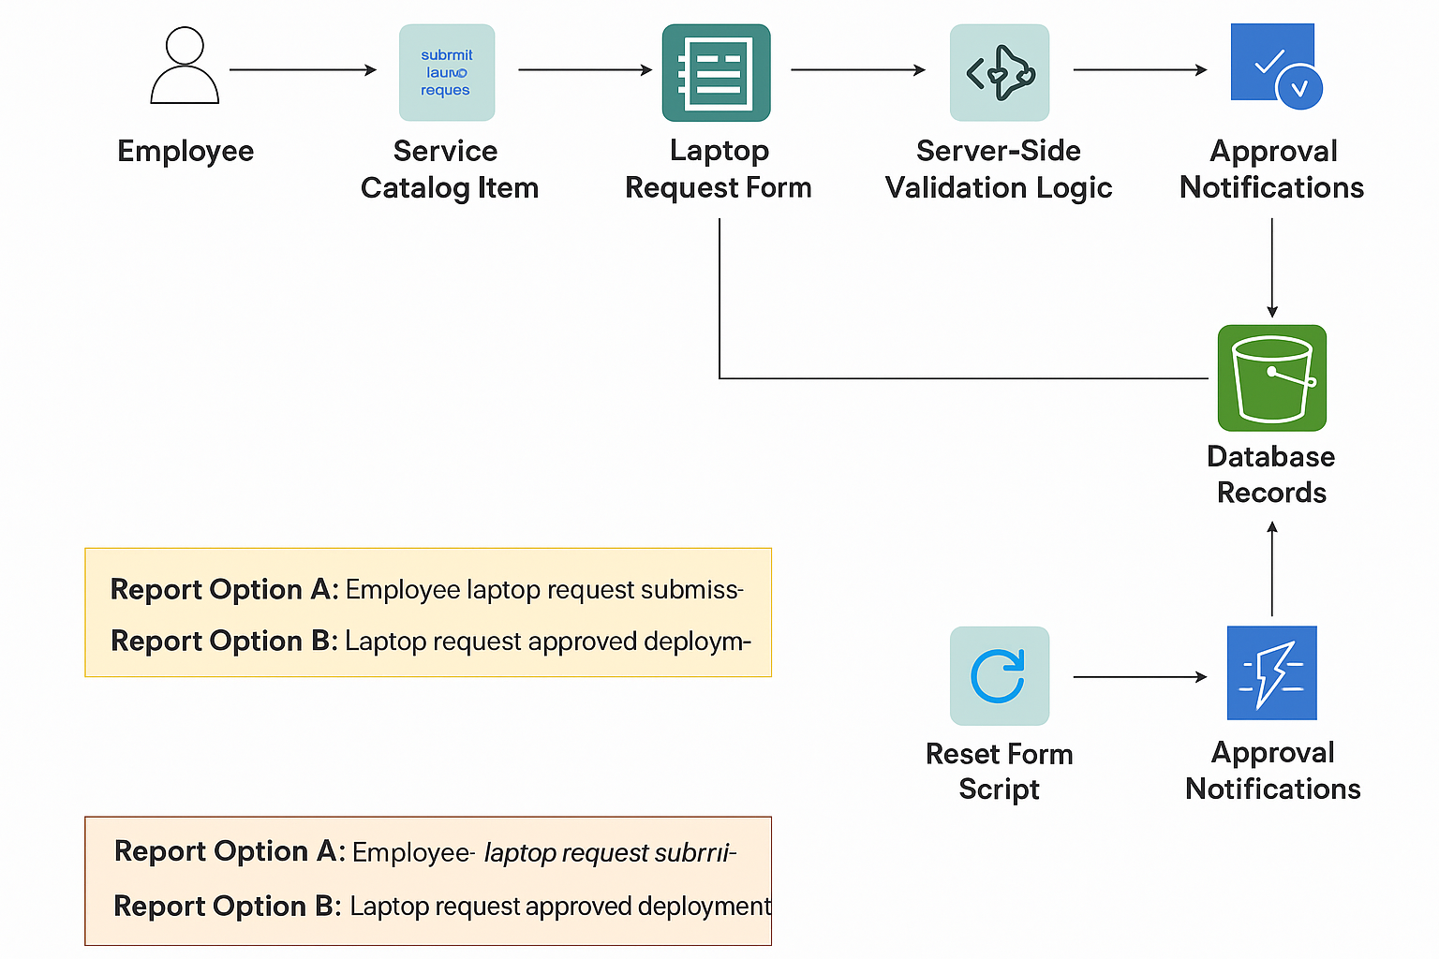

Figure 1: Solution Architecture of Laptop Request Catalog Item in ServiceNow

